Lab Exercise 3- Working with Docker Networking

Step 1: Understanding Docker Default Networks
Docker provides three default networks:
- bridge: The default network when a container starts.
- host: Bypasses Docker’s network isolation and attaches the container directly to the host network.
- none: No networking is available for the container.
1.1. Inspect Default Networks
Check Docker's default networks using:
docker network ls
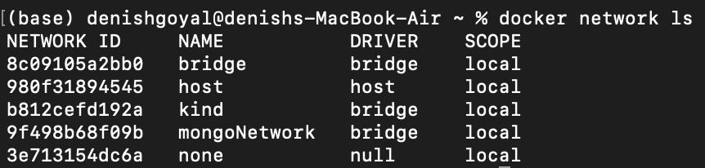

1.2.Inspect the Bridge Network
docker network inspect bridge
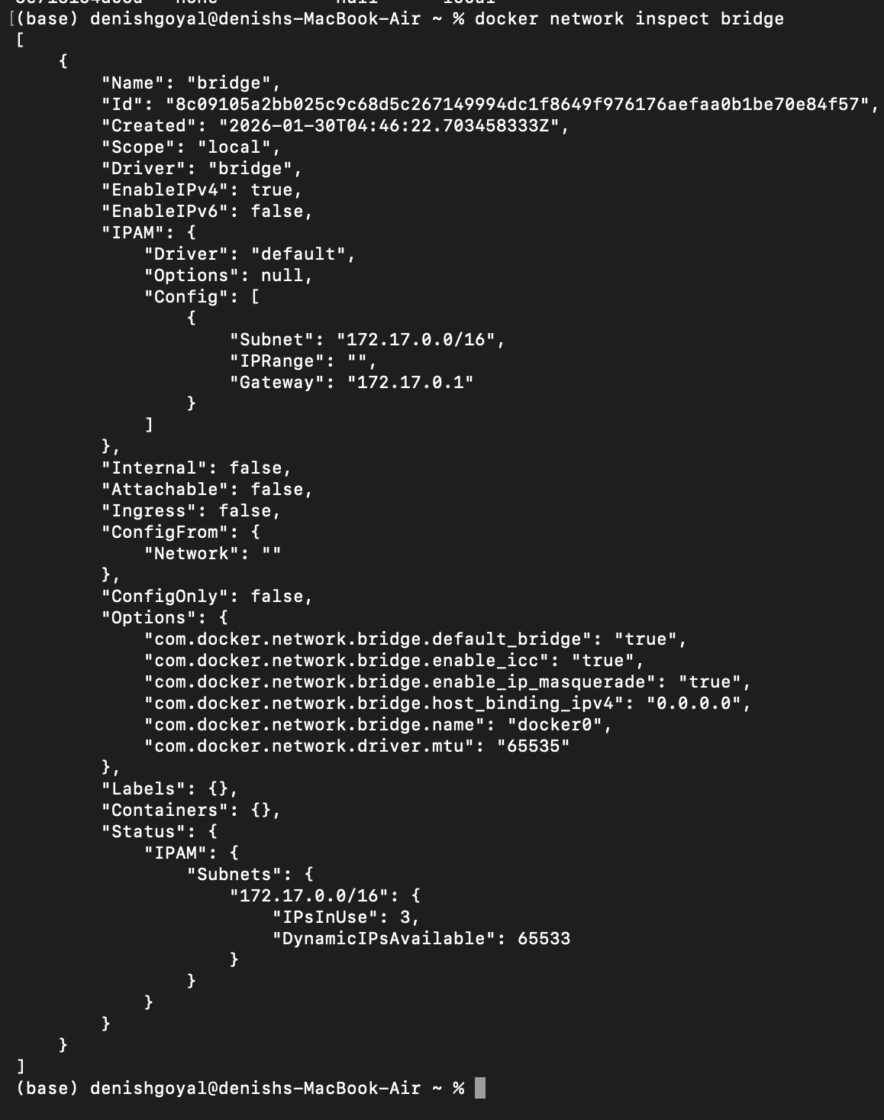
This command will show detailed information about the bridge network, including the connected containers and IP address ranges.
Step 2: Create and Use a Bridge Network
2.1. Create a User-Defined Bridge Network
A user-defined bridge network allows containers to communicate by name instead of IP.
docker network create my_bridge
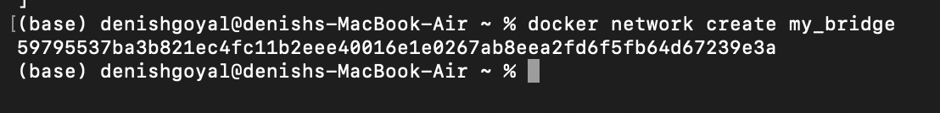
2.2. Run Containers on the User-Defined Network
Start two containers on the newly created my_bridge network:
docker run -dit --name container1 --network my_bridge busybox
docker run -dit --name container2 --network my_bridge busybox
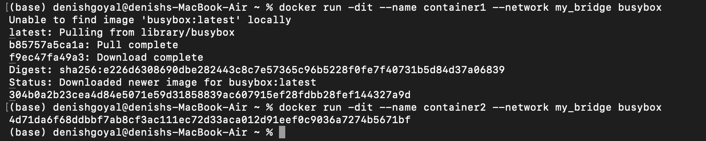
2.3. Test Container Communication
Execute a ping command from container1 to container2 using container names:
docker exec -it container1 ping container2
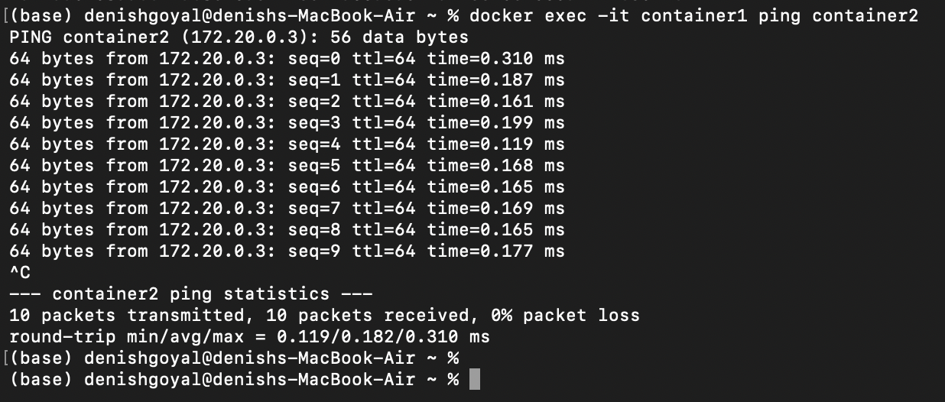
The containers should be able to communicate since they are on the same network.
Step 3: Disconnect and Remove Networks
3.1. Disconnect Containers from Networks
To disconnect container1 from my_bridge:
docker network disconnect my_bridge container1
4.2. Remove Networks
To remove the user-defined network:
docker network rm my_bridge
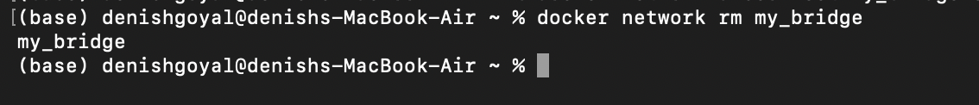
Step 4: Clean Up
Stop and remove all containers created during this exercise:
docker rm -f container1 container2
